**WEST NORTHAM PRIMARY SCHOOL BUSINESS PLAN 2025 – 2028**

**ACKNOWLEDGEMENT OF COUNTRY**

West Northam Primary School acknowledges the traditional owners of this Noongar land, who loved and cared for the land, animals, and waters of Ballardong country where our school resides.

We pay our respects to elders past and present; and thank the Ballardong people for sharing their land, culture, language, and history with us as we learn and play together.

**OUR MISSION**

Our motto at West Northam Primary School is Belong - Respect - Learn, where students learn to persevere and achieve their best. We foster a sense of belonging and support our students to respect, care and contribute to a positive school community.

**OUR BELIEFS ABOUT LEARNING**

We believe that students learn best …

* With high expectations and explicit learning goals that are purposeful, challenging and achievable.
* When teaching practices are regularly reflected on and evaluated for improvement.
* When student diversity is valued and students’ unique strengths, histories, cultures and languages are acknowledged.
* In a learning environment which prioritises student wellbeing and engagement.
* When the responsibility for student success is shared between the school, the family and the community.
* In an equitable learning environment that is culturally responsive.
* We believe that students become independent, life-long learners when engaged in relevant, purposeful learning experiences.

**POSITIVE BEHAVIOUR SUPPORT is about prevention, rather than intervention and explicitly teaching the students the skills to make good behaviour choices.**

Our staff are committed to teaching our students with kindness and compassion, applying Positive Behaviour Support (PBS) to establish our values of belong, respect and learn, and explicitly teaching the behaviour expectations linked to each value. PBS focuses on moving from 'Managing Student Behaviour' to 'Student Engagement' by building a sense of belonging and promoting a school culture in which students respect themselves and others; creating an inclusive environment where students can focus on their learning.

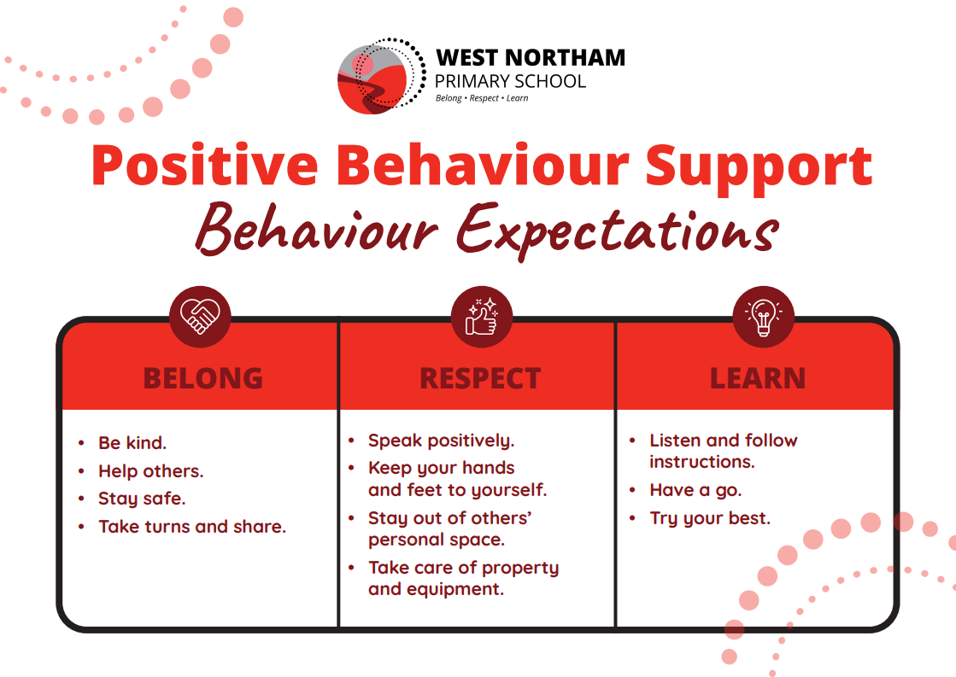

**RELATIONSHIPS AND PARTNERSHIPS**

We will establish clear communication procedures to ensure a positive, respectful and professional working and learning environment.

* We will follow our established Meeting Norms, sharing ideas in a positive and solution-focused manner.
* Staff will stay informed via established communication procedures.
* Staff will collaborate and meet established timelines.

We will build a strong, effective School Council consisting of diverse community members who contribute and add value to the future direction of the school.

* We will promote the role of the School Council within the community and provide information and training to members.
* We will liaise with community groups and businesses to promote membership.

We will continue to build and strengthen community partnerships that inspire student learning and support culture and diversity.

* Identify a community liaison to build relationships with the wider community to promote community engagement with the school.
* Use parent and community feedback from the School Culture Survey and other school-based surveys, to guide the school’s strategic direction.

**LEARNING ENVIRONMENT**

We will provide inclusive and responsive learning environments that recognise and respect all students’ cultures, beliefs and languages and where difference and diversity is celebrated.

* We will develop students’ intercultural understanding using a range of resources, including school and community members of diverse cultures.
* We will provide professional learning for staff in the teaching of intercultural understanding.
* We will provide an inclusive, culturally responsive learning environment that focuses on student wellbeing and engagement and results in attendance at or above that of like-schools.

We will provide opportunities for students to apply their voice to positively impact their learning journey.

* We will identify what student voice looks like at WNPS to ensure a shared understanding of how students can have a say in their learning.
* We will provide increased opportunities for the student leaders to plan and implement school activities which support student engagement and wellbeing.

We will ensure all staff have a shared understanding of differentiation to ensure the learning needs of all students are met.

* We will develop a whole-school document which defines and details the differentiation requirements for student learning to ensure consistency across the school.

**LEADERSHIP**

We will create an accountability framework to ensure staff are supported to implement changes with consistency and fidelity.

* We will provide staff with a definition of their roles and responsibilities as per the relevant JDF.
* We will implement consistent Performance and Development procedures designed to provide positive feedback, assist staff to identify areas for development and provide the training required to achieve their career goals.

**USE OF RESOURCES**

We will link allocated funding in Operational Plans to whole-school priorities.

* Cost Centre managers will be invited to attend Finance Meetings to ensure a common understanding of funding allocation and school priorities.
* The School Council will be encouraged to engage more in discussions around funding decisions and school priorities.
* Physical resources will be catalogued for ease of use.
* We will ensure that Allied Professionals are allocated and utilised effectively, to maximise their impact on student achievement, engagement and wellbeing.
* We will identify the needs of all students and allocate resources to best support their needs.
* Teachers will provide allied professionals with planning within a reasonable timeframe to allow them to perform their role effectively.
* Teachers will provide allied professionals with all documented plans and checklists to collect data and assess attainment of set goals.

**TEACHING QUALITY**

We will ensure that the implementation of whole-school programs is consistent, rigorous and with fidelity to improve student achievement and progress.

* We will provide staff with professional learning to upskill and review understanding of whole-school programs to ensure common language and practice in all classes.
* Performance and Development procedures, including coaching, mentoring and peer observations and feedback, will further ensure consistency and fidelity in the implementation of whole-school programs.
* Staff will share ideas and resources to improve teaching practices during regular planned sharing and collaborative meetings.

We will use The Teaching for Impact (TFI) and National Quality Standards (NQS) documents to guide planning, teaching and assessment to ensure we are using evidence-based, best practice in all classes.

* Teachers will collaborate and share planning and teaching practices and resources which are aligned with TFI and NQS.
* Early Childhood staff will collaborate with Admin regarding the NQS audit.
* The use of TFI and NQS practices will be discussed in Performance and Development.

**STUDENT ACHIEVEMENT AND PROGRESS**

We will continue to review our Assessment Schedule to ensure the data collected is relevant and useful in monitoring student achievement and progress.

* The assessment schedule will be reviewed annually in collaboration with teaching staff.
* We will have regular moderation sessions to ensure consistency in assessment practices in all classes.

We will analyse student achievement data to guide planning and teaching to improve student outcomes.

* Staff will collaborate to analyse student achievement data and reflect on the effectiveness of their teaching practices and implementation of whole-school programs to ensure our students achieve at or above like-schools in all NAPLAN tests.
* Teachers will provide explicit feedback to students regarding their achievement and progress and assist students to set challenging yet achievable targets for improvement.