
School Report 2025
School Overview
Our motto at West Northam Primary School is Belong - Respect - Learn, where students learn to persevere and achieve their best. We foster a sense of belonging and support our students to respect, care and contribute to a positive school community.

At West Northam Primary School, we offer your child a high-quality education in a safe, caring and culturally inclusive environment where all students can learn and grow.

Our highly skilled early childhood and senior team leaders work closely with staff to ensure our teachers use effective practices that provide excellence in teaching and learning for our students.

To prepare our students for an increasingly technological world, every classroom has an interactive LED panel, and we provide every student with an iPad or laptop to ensure the students receive the highest level of instruction using the latest in technology.

Positive Behaviour Support (PBS) is about prevention, rather than intervention and explicitly teaching the students the skills to make good behaviour choices. Our staff are committed to teaching our students with kindness and compassion, applying PBS to establish our values of belong, respect and learn, and explicitly teaching the behaviour expectations linked to each value. PBS focuses on moving from 'Managing Student Behaviour' to 'Student Engagement' by building a sense of belonging, promoting a school culture in which students respect themselves and others, creating an inclusive environment where students can focus on their learning.

Our school has strong partnerships with the community and regularly extends invitations to parents, friends and family members to visit the school for special events and to celebrate successes. Our P&C and the School Council work diligently to support the school and we welcome parents, carers, family and friends into our school and into our classrooms to build our partnership with you in your child’s education.

Student Numbers and Characteristics
Student Characteristics | Semester 1 | Semester 2
Aboriginal | 71 | 62
Non-Aboriginal | 70 | 68
Total | 141 | 130
With almost 50% Aboriginal student population, embedding Noongar language, culture, history and art into our students’ learning is a high priority at West Northam Primary School. We have two Aboriginal and Islander Education Officers (AIEOs), one who works three days a week, and teaches Noongar language to students from Years 3 to 6, and one full-time AIEO who started in Semester 2. Our AIEOs assist teachers both in class and with planning to help build cultural responsiveness in our teaching and learning. In addition, they lead the APAC Committee, (Aboriginal Perspectives Across the Curriculum) to develop our Reconciliation Action Pan and a plan each term to recognise important Aboriginal events such as Sorry Day, Reconciliation Week and NAIDOC.

Most of our EALD students have Aboriginal English as their first language, which further highlights the need for a focus on APAC across the school. In addition, to support all of our EALD students, our teachers use the WNPS Essential Components for Effective Lessons, aligned with the Teaching for Impact resources, and the Science of Reading strategies, to assist our EALD students with improving their understanding of Standard Australian English.

Each class is allocated an education assistant to assist in the delivery of differentiated learning for students at educational risk (SAER). Teachers adjust the learning program to cater for the individual needs of all students, providing targeted learning plans for education assistants to deliver to small groups or individual students.

The school invests in Professional Learning for staff on evidence-based literacy and numeracy programs to ensure we have effective teaching practices in every classroom and provide teachers with all the necessary resources to implement the programs successfully.

With over 76% of our students identified as having a social disadvantage, it is important that we provide our students with the support and skills needed to succeed. In a world which relies increasingly on technology, it is vital that we teach our students the skills they will need for the future. Every classroom has an interactive LED panel, and all students are provided with an iPad or laptop so that they can learn the skills necessary for future success in a digital world.

 | Workforce Composition
 | Administration Staff |  |  | Aboriginal |  |  | Non- Aboriginal
 | Principal/Deputy Principal |  |  | 0 |  |  | 1
 | Deputy Principal |  |  | 0 |  |  | 1
 | Teaching Staff |  |  | Aboriginal |  |  | Non- Aboriginal
 | Teaching Staff |  |  | 0 |  |  | 9
 | Allied Professionals |  |  | Aboriginal |  |  | Non- Aboriginal
 | Clerical/Administration Staff |  |  | 0 |  |  | 2
 | Instructional |  |  | 2 |  |  | 9
 | Non-instructional |  |  | 0 |  |  | 4
 | Total |  |  | 2 |  |  | 26
 | Comments:
At West Northam PS in 2025, we had six classes from Kindergarten to Year 6. We have one specialist teacher who teaches the Arts (music and visual arts), Physical Education, and Design and Technology to students from Year 1 to Year 6. We have an early childhood specialist teacher who provides DOTT to our Kindergarten to Year 2 students; and an AIEO who teaches Noongar Language to the students from Year 3 to Year 6.

With a high percentage of Aboriginal students, we believe that learning the local Noongar Language together with Aboriginal culture, history and art, is essential for all students at West Northam. After trying to recruit a second AIEO for several years, we succeeded in finding a second, full-time AIEO, who started in Semester 2.

In the Administration team, we have a principal, a deputy principal, a part-time school officer and a full-time manager of corporate services. Our school officer is also our librarian.

We have a senior teacher who works one day a week to provide in-class coaching to our graduate teacher to improve her teaching practices and ensure consistency in teaching and learning across the school.

In 2025, we received 3.2FTE in disability resourcing, and the State Government provides funding for 1.5FTE mainstream education assistant (EA) time.

The school funds an additional 1.0FTE special needs EA (SNEA) time, and 2.3FTE additional mainstream EA time, making a total of 4.2FTE SNEA time and 3.8FTE mainstream EA time, to ensure we are meeting the National Quality Standards (NQS) for Early Childhood learning, to provide MiniLit intervention for students who are having difficulty with literacy, and to provide additional support to students in classes as we have a high number of students with imputed disabilities, who have additional needs, but do not qualify for targeted, supplementary funding through the individual disability allocation process.
 | Student Attendance
 | Semester 1 2025
 | Non-Aboriginal |  | Aboriginal |  |  | Total
 | WNPS | Like Schools | WNPS |  | Like Schools | WNPS |  | Like Schools
 | 89.1% | 88% | 66% |  | 67.1% | 78.4% |  | 89.1%
Our overall attendance in Semester 1 2025, showed a decrease of 1.8% from 2024. While our non-Aboriginal student attendance increased by 1.6%, it was the drop in attendance of 4.5% in our Aboriginal student attendance, which resulted in an overall decrease.

Our Aboriginal attendance was below like-schools in 2025, for the first time in over 12 years. Like many schools, we are seeing an increasing number of school refusals, often related to mental health or children on devices until late at night; however, this is an indication that we need more communication with families to build better relationships, trust and connection in order to re-engage students with their learning.

To follow up on absences, our AIEO phones families regarding unexplained absences each week, and both the deputy principal and AIEO do regular home visits to assist parents/carers to get their children to school.

To improve both attendance and communication with families, in 2021 we developed a Parent Communication Plan which included parent/carer - teacher meetings twice a year in Terms 1 and 3, to talk to parents/carers about how their children are going at school. This provides an opportunity for teachers to ask parents/carers about their expectations and aspirations for their children, and how they can work together to get the best outcomes for students.

At these meetings, for identified students, the teachers will ask the parents/carers about possible reasons why their child may be reluctant to attend school and discuss strategies for both the school and the parents/carers which might help to improve their child’s attendance.

Student Achievement and Progress
NAPLAN 2025
NAPLAN 2025 STUDENT ACHIEVEMENT
 |  | YEAR 3 |  |  | YEAR 5
 |  | ALL STUDENTS | LIKE SCHOOLS | STABLE COHORT | ALL STUDENTS | LIKE SCHOOLS | STABLE COHORT
NUMERACY | EXCEEDING | 0% | 3% | 0% | 0% | 0% | 0%
NUMERACY | STRONG | 20% | 27% | 18% | 31% | 29% | 23%
NUMERACY | DEVELOPING | 33% | 34% | 36% | 44% | 36% | 54%
NUMERACY | NEEDS ADDITIONAL SUPPORT | 47% | 36% | 46% | 25% | 35% | 23%
READING | EXCEEDING | 0% | 7% | 0% | 6% | 4% | 5%
READING | STRONG | 40% | 25% | 27% | 13% | 29% | 29%
READING | DEVELOPING | 20% | 24% | 27% | 56% | 26% | 22%
READING | NEEDS ADDITIONAL SUPPORT | 40% | 45% | 46% | 25% | 41% | 42%
WRITING | EXCEEDING | 0% | 1% | 0% | 6% | 2% | 3%
WRITING | STRONG | 40% | 48% | 36% | 6% | 27% | 27%
WRITING | DEVELOPING | 40% | 18% | 43% | 69% | 30% | 64%
WRITING | NEEDS ADDITIONAL SUPPORT | 20% | 33% | 21% | 19% | 40% | 18%

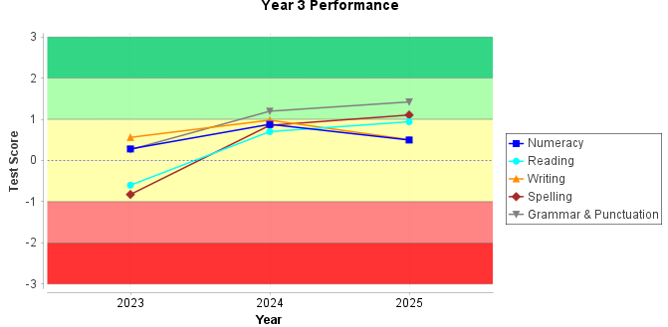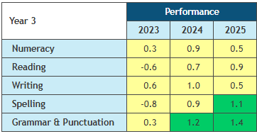

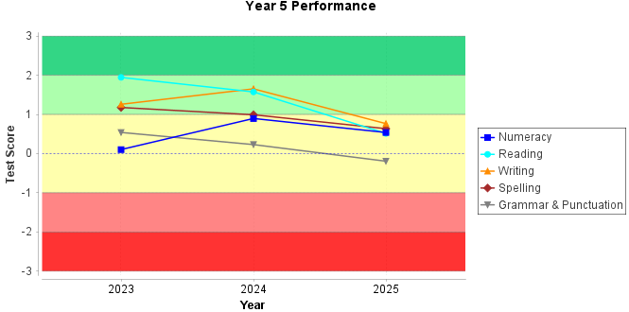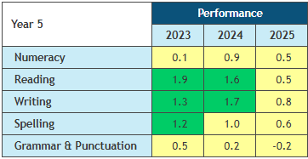
The Year 3 students achieved within one standard deviation of expected scores based on past performance in numeracy, reading and writing, and above expected scores in spelling and grammar and punctuation. The performance of the Year 3 students in reading spelling and grammar and punctuation improved from 2024 to 2025; however, they have dropped in numeracy and writing.

The Year 5 students achieved within one standard deviation of expected scores based on past performance in all tests. However, there is a decrease in scores for all tests in 2025, after showing stronger performances in 2023 and 2024.

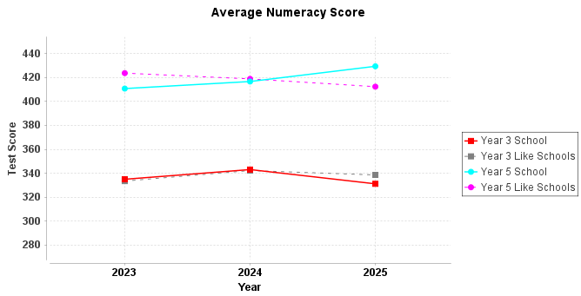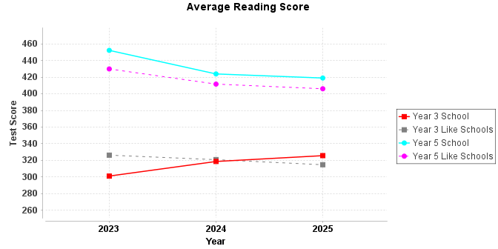

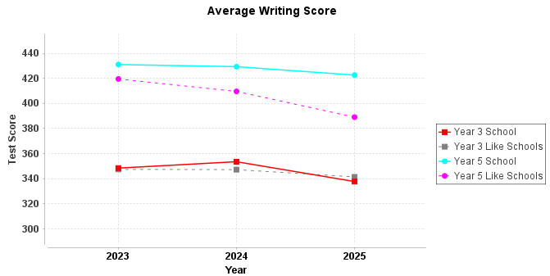

In 2025, the Year 3 students have stayed closely aligned with like-schools in numeracy and writing, although they have dropped slightly below like-schools in both. In reading, the Year 3 students have progressed from below like-schools in 2023, to the same as like-schools in 2024, and above like-schools in 2025. Similarly, in numeracy, the Year 5 students have progressed from below like-schools in 2023, to the same as like-schools in 2024, and above like-schools in 2025. While the Year 5 scores in reading and writing have decreased, they still remain above like-schools.

To support students who are experiencing difficulty in reading, we have one EA who delivers an intensive reading program, MiniLit Sage, to small groups or individual students outside the classroom, plus EAs who work with students inside the classroom to consolidate what they have learnt during the withdrawal program. In addition to MiniLit Sage, the EA also does MacqLit with students in Years 3 to 6, who need additional assistance with literacy, to help improve the progress of students from Year 3 onwards.

With a focus on improving numeracy and literacy, teachers use Teaching for Impact strategies while implementing Seven Steps Writing, PLD Spelling and Top Ten Maths to ensure consistent and effective teaching practices across the school.
PRE-PRIMARY ON-ENTRY 2025
Achievement | Numeracy |  | Reading |  | Writing
 | All Students | Like Schools | All Students | Like Schools | All Students | Like Schools
Top 20% | 25% | 5% | 13% | 7% | 13% | 18%
Middle 60% | 25% | 46% | 75% | 44% | 38% | 32%
Bottom 20% | 50% | 49% | 13% | 48% | 50% | 50%

NUMERACY READING WRITING
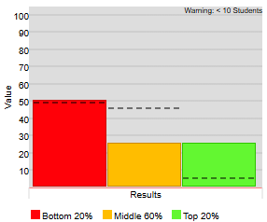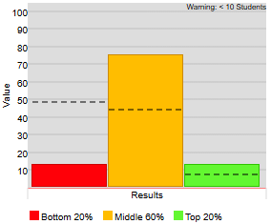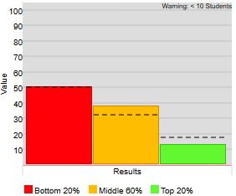

The Pre-primary students showed encouraging results in the 2025 On-Entry testing, performing well above like-schools in numeracy and reading, with 20% more students in the top 20% in numeracy, and 31% more students in the middle 60% in reading. They performed at a similar level to like-schools in writing.
YEAR 1 ON-ENTRY 2025
Achievement | Numeracy |  | Reading |  | Writing
 | All Students | Like Schools | All Students | Like Schools | All Students | Like Schools
Top 20% | 10% | 9% | 10% | 14% | 0% | 11%
Middle 60% | 30% | 52% | 20% | 42% | 27% | 46%
Bottom 20% | 60% | 38% | 70% | 44% | 73% | 42%
Year 1 Numeracy
Achievement Progress
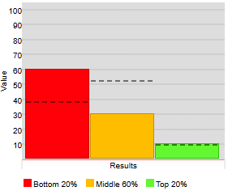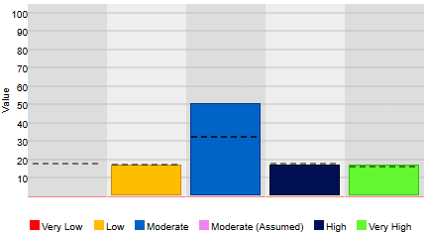
Year 1 Reading
Achievement Progress
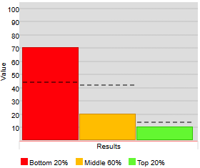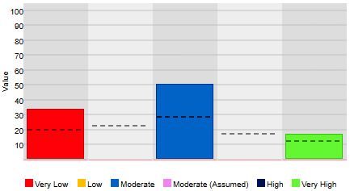

Year 1 Writing
Achievement Progress
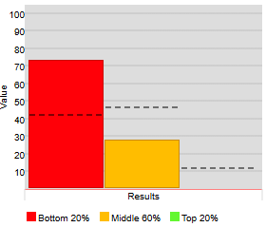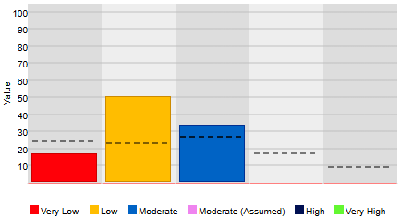

The Year 1 students have scored below like-schools in On-Entry numeracy, reading, and writing; and while the progress from Pre-primary to Year 1 in numeracy is above like-schools, the low progress in reading and writing is a concern.

The low achievement and progress of the Year 1 students will continue to be addressed through our whole-school programs, Seven Steps Writing, Top Ten Maths and PLD phonics/spelling, using the strategies described in the Department’s Teaching for Impact documents, with targeted support for identified students through the MiniLit program.

YEAR 2 ON-ENTRY 2025
Achievement | Numeracy |  | Reading |  | Writing
 | All Students | Like Schools | All Students | Like Schools | All Students | Like Schools
Top 20% | 5% | 9% | 10% | 10% | 5% | 9%
Middle 60% | 71% | 39% | 38% | 41% | 59% | 45%
Bottom 20% | 24% | 52% | 52% | 49% | 36% | 46%

Year 2 Numeracy
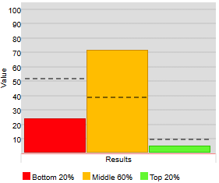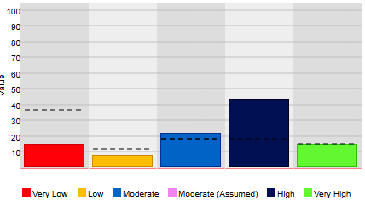

Year 2 Reading
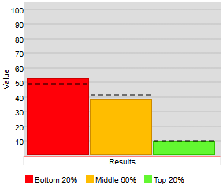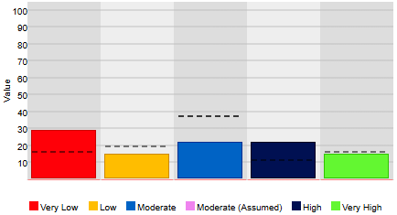

Year 2 Writing
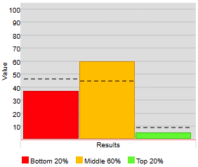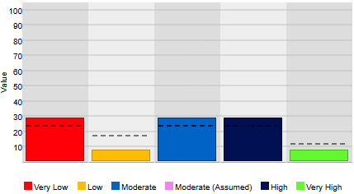

The results of the Year 2 On-Entry tests show that the students have scored above like-schools in numeracy and writing, and very close to like-schools in reading. The progress in numeracy is encouraging with the students showing much higher progress than like-schools, and a similar level of progress in writing; however, the progress in reading is below like-schools.

Again, the students will continue to be supported through our whole-school programs, Seven Steps Writing, Top Ten Maths and PLD phonics/spelling, using Teaching for Impact strategies, with targeted support for identified students through the MiniLit program.
School Surveys
All government schools in WA are required to complete staff, student and parent surveys every two years. In 2025, we did not complete the mandated surveys as they were done in 2024; however, each year, all Wheatbelt students complete a Social and Emotional Wellbeing survey to collect data on the social and emotional wellbeing of our students.

STUDENT SOCIAL AND EMOTIONAL WELLBEING SURVEY 2025

The Kindergarten to Year 2 students do the Social and Emotional Wellbeing survey one-on-one with their teacher. The teacher gives the students a series of statements which require a ‘Yes’ or ‘No’ response. Teachers may rephrase or explain the questions to ensure that the students understand what is being asked.

Social and Emotional Wellbeing Survey 2025 – Years K to 2
Statements |  | % Yes
1 | If I wasn't at school, someone would miss me | 86
2 | I have friends at school | 97
3 | When I have a problem I know how to get help | 94
4 | I like coming to school every day | 86
5 | I feel safe at school | 92
6 | I believe I can do hard things if I keep trying | 81
7 | I know three things that I do well | 81
8 | I know how to make myself feel better if I get upset | 86
9 | My classmates are kind to me | 97
10 | My teacher likes me | 92
Average percentage |  | 89

It is pleasing to see that such a high percentage of K to 2 students have friends at school and feel that their classmates are kind to them, and that over 90% believe their teacher likes them, feel safe and know how to get help when they have a problem.

The scores for the K to 2 students in 2025 are higher than 2024, where we had an average percentage of 85%, the highest percentage was 92%, and the lowest two percentages were below 80%. As for 2025, the highest percentage in 2024 was Statement 2, but the lowest two percentages were Statements 5 and 8, which scored much higher in 2025. While it is encouraging to see those percentages both improve in 2025, it is concerning to see the percentages of Statements 6 and 7 drop below those in 2024, with a drop of 10% for Statement 7.

The low percentages for Statements, 6 and 7, at only 81%, suggest that the students lack confidence in their ability to succeed in their learning, so work needs to be done to ensure our teachers adjust the learning for students so that they are working at their level and able to experience success at school.

In the Social and Emotional Wellbeing survey for Years 3 to 6, the students are given a series of statements which they score from 1 to 5, with 1 being ‘strongly disagree’, 2 being ‘disagree’, 3 being ‘unsure’, 4 being ‘agree’ and 5 being ‘strongly agree’, so the higher the score for each statement, the greater the social and emotional wellbeing of the students.

Social and Emotional Wellbeing Survey 2025 – Years 3 to 6
Statements |  | Score/5
1 | I like coming to school | 4
2 | I feel safe at school | 4
3 | I have friends at school | 4.3
4 | People care about each other in my class | 3.5
5 | My teacher cares about me | 4.4
6 | Adults treat students kindly & fairly at this school | 4.1
7 | I am interested in what I am learning in class | 3.9
8 | I am a good learner | 3.9
9 | I know how to be a good classmate and friend | 4.1
10 | If I have a problem, I can solve it or find someone who can help me solve it | 3.7
11 | I feel OK when I make mistakes, because I learn from them | 4
12 | I can finish work, even when it is tough | 4
13 | I can tell when someone is upset | 4
14 | I work well with others in my class | 4
15 | I know what to do to calm myself down when I get upset | 3.7
16 | I can do some things really well | 3.9
17 | I like the way I am | 4.1
18 | I feel like I belong at my school | 3.8
Average score |  | 4

The average score for Years 3 to 6 was slightly lower in 2025 compared to the average of 4.1 in 2024. Statements 3 and 4 remain those with the highest scores, and similarly, Statements 4 and 15 are the lowest.

These scores indicate that more work needs to be done in teaching students the skills to recognise and regulate their emotions, and to interact positively with others. While the school has been implementing Positive Behaviour Support for many years to explicitly teach students the skills to make positive behaviour choices, we have recognised a need for a more restorative approach to support students to make those positive choices.

To improve our students’ ability to self-regulate and interact positively with others, in 2026 and 2027, the whole staff will be doing Berry Street Education Model (BESM) training with a view to moving towards a more trauma-informed, restorative practice across the school. BESM focuses on providing staff with evidence-based strategies and tools which cater for the different learning needs of students, thereby improving student engagement, wellbeing, self-regulation, relationships and academic achievement.
School Funding
Our cash budget for 2025 was $420,000, increased from $350,000 to reach our minimum expenditure; however, we did not spend the full amount, and as a result, we did not meet our minimum expenditure for 2025.

At West Northam PS, we rely solely on our Student-Centred Funding, as we receive very little in Voluntary Contributions. Our Voluntary Contributions have remained at $20 per child for over 10 years, and in 2025, we received $480.00 from a possible $2,820, for 141 students in Semester 1.

Utilities and Maintenance accounted for around 30% of our total cash budget in 2025. With extensive grounds, and with Northam having the second highest water usage charges in WA, water charges account for 66% of the Utilities and Maintenance costs, and 20% of our total cash budget in 2025.

In 2025, 30% of our cash budget covered items related directly to teaching and learning, such as equipment, curriculum resources, student services and professional learning to improve teaching practices. Another 30% of our cash budget covered items such as minor building works and repairs, freight, postage, furniture, office equipment and student graduation and awards, and the remaining 10% of our cash budget went into our reserve accounts for our Asset Replacement Plan for ICT, furniture and photocopiers, to ensure we have the money to replace these items each year.

When budgeting, we ensure that the priorities and focus areas outlined in our School Plan, are allocated sufficient funds for the professional learning and resources required for whole-school learning programs to be delivered effectively to improve student outcomes.

Operational One Line Budget Statement 2025
School: | West Northam Primary School | Dec 2025 (Verified Dec Cash)
Region: | Wheatbelt Region
 |  | Current Budget | Actual YTD | Variance
Carry Forward (Cash): |  | $ 129,218 | $ 129,218 | 0
Carry Forward (Salary): |  | $ 237,189 | $ 237,189 | 0
INCOME
Student-Centred Funding (including School Transfers & Department Adjustments): |  | $ 2,626,771 | $ 2,626,771 | 0
Locally Raised Funds: |  | $ 15,073 | $ 25,530 | -$10,457
Total Funds: |  | $ 3,008,250 | $ 3,018,708 | -$10,457
EXPENDITURE
Salaries: |  | $ 2,318,553 | $ 2,318,553 | 0
Goods and Services (Cash): |  | $ 420,474 | $ 366,486 | $53,988
Total Expenditure: |  | $ 2,739,027 | $ 2,685,039 | $53,988
Variance: |  | $ 269,224 | $ 333,669 | -$64,445

IDENTIFIED CONCERNS | TARGETS | Planned actions
NAPLAN progress from Year 3 to Year 5. | 2026  - Improve progress from Year 3 to Year 5 NAPLAN.  - Achieve at or above like-schools in all NAPLAN tests.  2024 NAPLAN compared to like-schools.  Year 3  - Numeracy – same  - Reading – above  - Writing – same  Year 5  - Numeracy – same  - Reading – above  - Writing – above  2025 NAPLAN compared to like-schools.  Year 3  - Numeracy – below  - Reading – above  - Writing – same  Year 5  - Numeracy – above  - Reading – above  - Writing – above | 2025  - Continuation of MultiLit intervention for Year 1 to 6.  - The Year 5 students are maintaining or improving on their Year 3 NAPLAN results, so in 2025 we will continue to monitor effective implementation of PLD Phonics/Spelling, Seven Steps Writing and Top Ten maths via classroom walk-throughs and data collection and analysis.
NAPLAN progress from Year 3 to Year 5. |  | 2026  - Continuation of MultiLit intervention for Year 1 to 6.  - The drop in Year 3 NAPLAN numeracy results to below like-schools indicates that a greater focus on fidelity and consistency in the implementation of Top Ten Maths is needed in the early years.  - In Term 4, formal data analysis sessions were introduced to specifically identify target students and document strategies for improvement. In 2026, regular data analysis sessions will continue to take place each term.
Student Attendance. | 2026  - Improve student attendance to at or above like-schools. | 2025  - After the reinstatement of attendance agreements in Semester 1 2025, we will review of the process of the agreements, in collaboration with teachers, to ensure the plans are implemented effectively and lead to improved attendance and discuss any changes that need to be made to improve the process.
Student Attendance. |  | 2026  - We found that the formal attendance agreements were inconsistent and it was difficult to ensure the consistency of implementation of the plans at home, so at parent/carer meetings, teachers talked more informally about possible reasons why their child may be reluctant to attend school and strategies that the school could use that might help to improve their child’s attendance.  - In 2026, we will increase the frequency of home visits by our attendance officers, as we believe that regular contact with families is an effective way to improve attendance.
Staff and student participation in decision-making. | 2026  - Increase staff participation in decision-making.  - Provide opportunities for student voice across the school. | 2025  - Examine issues related to student achievement and progress using CCPS and collaborative meetings in phases of learning.
Staff and student participation in decision-making. |  | 2026  - The WNPS School Plan was developed collaboratively with all staff in 2025, and in 2026, our Behaviour and Engagement Plan will be reviewed and updated collaboratively with all staff.  - Other decisions related to the school’s processes and procedures will continue to be discussed in meetings with the appropriate committees, e.g. Workload Advisory Committee, Positive Behaviour Support Team, Finance Committee, APAC Committee, who are continuing to develop our Reconciliation Action Plan (RAP) in 2026, and our new Health and Wellbeing Committee, who will be developing a Health and Wellbeing Plan in 2026.  - Minutes and draft plans made by each committee are shared with all staff and feedback requested.
Parent Communication. | 2026  - Improve parent communication processes.  - Reintroduce AIEO morning teas. | 2025  - Review Parent Communication Plan to improve parent communication and increase opportunities for parent feedback.  - Have an AIEO morning tea for Aboriginal families and community elders every term to engage more Aboriginal families and get feedback regarding their expectations of the school and their aspirations for their children.
Parent Communication. |  | 2026  - Only one AIEO morning tea took place in 2025. In 2026, ensuring the morning teas take place each term will be the responsibility of the APAC Committee, who will include them in their term planners.  - In 2026, classes will be collapsed for parent/carer meetings to take place in Terms 2 and 3, to encourage greater communication and opportunities for teachers to strengthen relationships with parents/carers.
Data Analysis | 2026  - Improve data analysis processes to identify and address areas of need. | 2025  - Introduction of Elastik to collect and analyse student performance data, then address identified gaps in student learning.
Data Analysis |  | 2026  - We found that the Elastik assessments were too wordy and difficult for students from PP to Year 2, and that Brightpath was a better option for assessing writing.  - We will continue to use Elastik for Years 3 to 6, and On-Entry and assessments from our whole-school programs for PP to Year 2. Brightpath will be used from PP to Year 6 for writing assessment and moderation.  - Data analysis sessions will take place each term to identify and document target students and strategies for improvement.

Endorsed by School Council Chair: Name___________________________ Signature___________________________ Date______________

Principal: Name___________________________ Signature___________________________ Date______________

