

STUDENT BEHAVIOUR AND ENGAGEMENT PLAN

Our Purpose:
At West Northam Primary School, our students learn to persevere and achieve their best. We foster a sense of belonging and support our students to respect, care and contribute to a positive school community.

Our Beliefs About Behaviour:
- Behaviour serves a purpose – it is designed to either get or avoid something.
- Explicitly teaching expected behaviours decreases negative behaviours.
- Positive language reinforces behaviour expectations.
- Positive feedback must be immediate and specific.
- Active supervision is critical and non-negotiable.
- Clear and consistent procedures in the classroom and playground will promote positive behaviours.
- High levels of student engagement will promote positive behaviours.
- By following 123 Magic and Emotion Coaching for minor behaviours, we allow students the opportunity to respond appropriately to instructions.
- Negative behaviours should be responded to immediately and in a calm manner.
- Staff model and reinforce appropriate behaviours.
- The matrix will be displayed in all areas of the school to reinforce positive behaviours.

What is Positive Behaviour Support?
POSITIVE BEHAVIOUR SUPPORT is about prevention, rather than intervention and explicitly teaching the students the skills to make good behaviour choices.
We aim to make West Northam Primary School a safe and productive learning environment by applying Positive Behaviour Support (PBS) to establish our values of belong, respect and learn, and explicitly teaching the behaviour expectations aligned with each value. The link between student achievement and student behaviour is clear, therefore we want students who are on task and authentically engaged in their learning. Our PBS Team meets twice a term to support the implementation and sustainability of PBS via evidence-based strategies.
Our PBS Team’s purpose is to establish a process that will enhance the development of a positive school culture, a consistent approach with clear expectations, and a common language used by everyone. Decisions are evidence-based, relevant to WNPS and regularly reviewed. Staff, students and the school community are consulted and informed to ensure understanding and ownership of our PBS processes and procedures.

WEST NORTHAM PRIMARY SCHOOL PBS PROCEDURES
PBS is based on the explicit teaching of expected behaviours that are positively stated. Staff, students and the PBS Team have collaboratively constructed a behaviour matrix displaying the WNPS behaviour expectations, which are visible in all areas of the school.
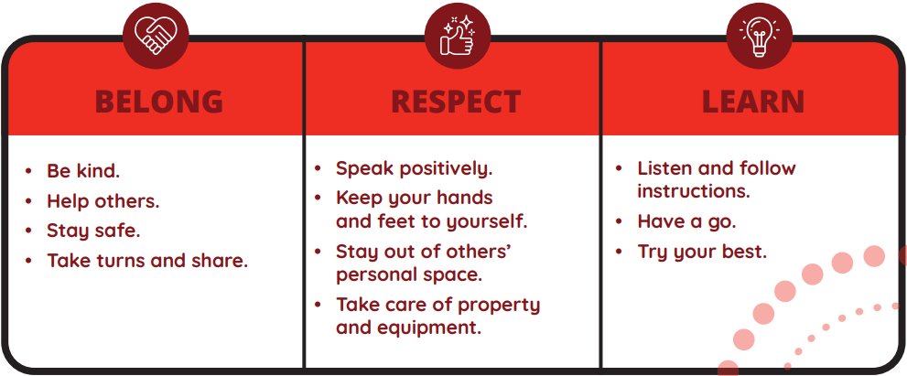
Students are rewarded with deadlies for demonstrating our expected behaviours, and when giving the deadlies, staff state the behaviour demonstrated, e.g. “Thank you for taking turns and sharing.”
We have a schedule of ‘focus behaviours’ from the Matrix which are explicitly taught and referred to daily in class. Deadlies given out for the current ‘focus behaviour' go onto the Recognition Board in each classroom. In Weeks 3, 6 and 9 each term, two deadlies from every class are drawn from the class raffle box and the winners receive prizes at Rocket Assembly for the positive behaviours they have demonstrated.
Every day, students with Good Standing will receive an extra 15 minutes of playtime before lunch. To retain their Good Standing, students must follow our school behaviour expectations under our school values of belong, respect and learn, as stated in the West Northam Primary School Behaviour Matrix.
In addition, at the end of the week, each adult in the class (i.e. teachers and EAs/AIEOs) will choose one student each, as their ‘Star of the Week’. On Friday afternoon, the chosen students will receive a ‘Star of the Week’ card, and each Monday afternoon, the ‘Stars of the Week’ will have a reward, such as an afternoon tea with Admin.
RESPONDING TO INAPPROPRIATE BEHAVIOURS:
Students are going to make behaviour errors. By viewing these errors as opportunities to re-teach and re-direct, we can be objective and professional with our responses to students. At West Northam PS, we use 1-2-3 Magic and Emotion Coaching to correct inappropriate behaviour.
1-2-3 Magic and Emotion Coaching consists of five main components:
- Teach them and show them – the students are explicitly taught expected behaviours which are then modelled consistently by staff.
- Encourage and prompt them – staff build positive relationships with students while encouraging and prompting expected behaviours.
- Set limits – expectations, procedures and consequences are explicitly taught and implemented consistently across the school.
- Manage circumstances – the teacher manages the classroom environment to maximise student engagement, taking into consideration organisation, lesson content and delivery.
- Consequences – consequences for inappropriate behaviour are predictable, consistent and relative to the behaviour.

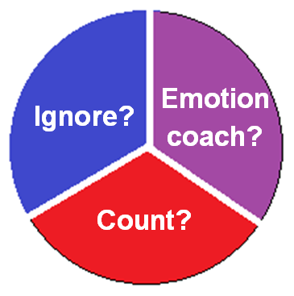
BEHAVIOUR MANAGEMENT PROCEDURES:
When a student misbehaves, the teacher has three choices:
- Ignore? – minor behaviours can often be ignored and managed by the following low-key strategies:
  - Planned Ignoring: Ignore minor behaviours that do not disrupt others, preventing unnecessary conflict.
  - Proximity: Move and stand near a student who is off task while continuing to teach.
  - Pause: Stop talking abruptly to signal that behaviour is inappropriate and wait for attention to return.
  - Non-Verbal Cues: Use facial expressions (e.g. frown, raised eyebrows), a ‘stop’ hand gesture (e.g. hand up), or shaking your head.
  - Using the Student's Name: Incorporate the name of an off-task student into your instruction, for example, "So, Sally, when we calculate the area...".
  - Private Dialogue: When a behaviour persists, have a quiet, one-on-one conversation rather than calling them out in front of the class.
  - Physical Intervention: Gently touching the object causing a distraction, e.g. a tapping pencil or spinning chair.
  - Positive Redirection: Instead of highlighting the inappropriate behaviour, thank a nearby student for doing the right thing, e.g. "Thank you for opening your book, Billy.”

- Emotion Coach? – if the behaviour has not yet escalated, emotion coaching can be a better way of managing the student’s behaviour:
- Be aware of the student’s emotion.
- Recognise the emotion as an opportunity for relationship building and teaching.
- Listen empathetically and validate the student’s feelings.
- Help the student verbally label their emotions.
- Acknowledge when a student is being too hot (aggressive), too cold (passive) or just right (assertive) when emotion coaching.
- Set limits while helping the student to solve the problem.
- Check that the student knows what to do and assist or adjust if necessary.
- Reflect on the function of the child’s behaviour, identify what are they trying to get or avoid and address the need.
- Consider whether the four Universal Needs of belonging, mastery, independence and generosity are being met.
When emotion coaching, teachers should always refer to the matrix of expected behaviours.
- Count? – if a student is exhibiting unacceptable behaviours, they will be counted. When counting, staff will be:
- Immediate – respond as soon as the behaviour occurs.
- Calm – use a low, composed tone of voice.
- Brief – keep talk to a minimum.
- Specific – state the expected behaviour.
- Consistent – respond the same way to all students every time.
- Discreet – be as inconspicuous as possible, e.g. hold up fingers to show the count, or speak quietly to the student.
If the count reaches three, the student will be instructed to reset. The purpose of reset is to interrupt the inappropriate behaviour and remind the student of the expected behaviour. It gives the student an opportunity to reflect, reset and be ready to learn. Once the reset is completed, the student returns to work.
If a student refuses to do reset, they are reminded that they are choosing ten minutes’ time-out at recess or lunchtime. If the student still refuses to do the reset, they are told that they have chosen ten minutes’ time-out at recess or lunchtime, and they now need to return to work.
N.B. If the student chooses ten minutes’ time-out at recess or lunchtime, they DO NOT need to do the reset. The choice is reset OR time-out, NOT BOTH.
The student is given some take-up time to return to work (one or two minutes, depending on the student, unless otherwise stated in an IBMP). If the student does not return to work, the teacher will choose whether to count or emotion coach.
If the student reaches a second reset and refuses again, a member of the Administration Team will come to the class and supervise the reset. The purpose of this is for the student to become accustomed to doing a reset in class so that they can use the reset process to self-regulate and be ready to learn.
After every third reset, students will have ten minutes’ time-out at recess or lunchtime.
The classroom counting procedure is set out in a flow chart which is displayed in all classrooms, (see Appendix A).
Major Behaviours or repeated Minor Behaviours may result in suspension for Years 1 to 6. As an alternative for suspension, in Kindergarten and Pre-Primary the following will apply:
In-class withdrawal for half a day from outdoor and classroom play activities; (8:45am to 11:45pm OR 11:45pm to 2:55pm).
Students who demonstrate persistent inappropriate behaviour need to have an informal contract or an Individual Behaviour Plan (IBP), (see Appendix B). In addition to the IBMPs, each class will have a class 123 Magic and Emotion Coaching plan detailing the specific processes in that class, (see Appendix C).
Appendix A
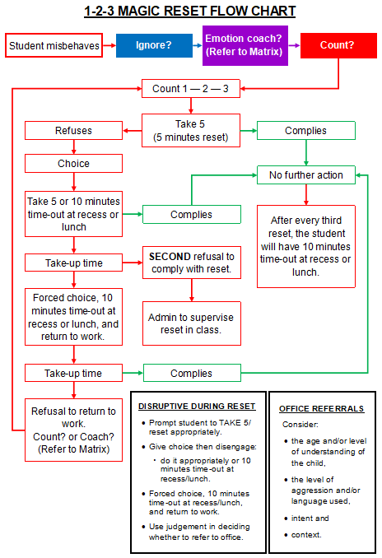
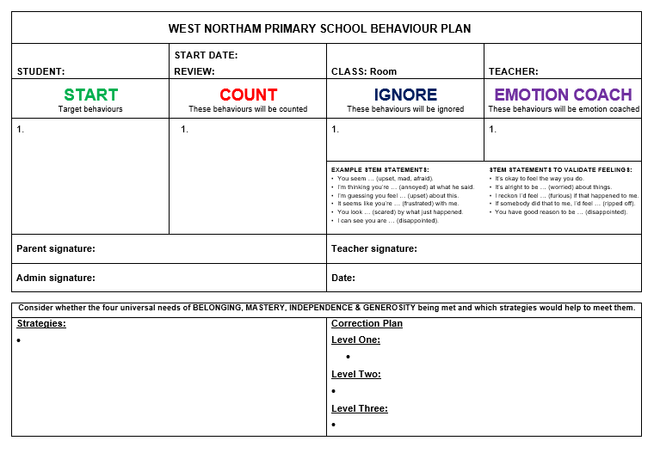
Appendix B
Appendix C

